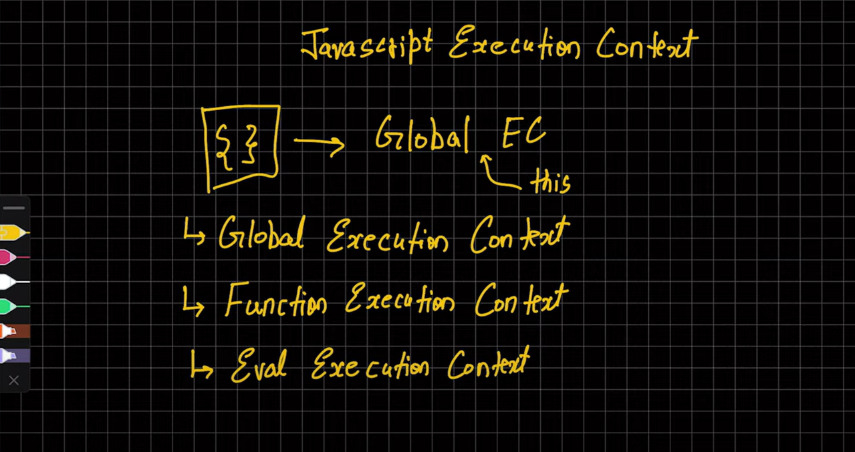

Whenever ANY JS CODE is run then first Global Execution context is created and kept in ‘THIS’ Keyword differently on console and node.js, on console This is treated as a windows object and on node.js This keyword KI VALUE an empty object aati cause of difference in boths GEC.

PHASES IN EXECUTION OF ANY JS CODE

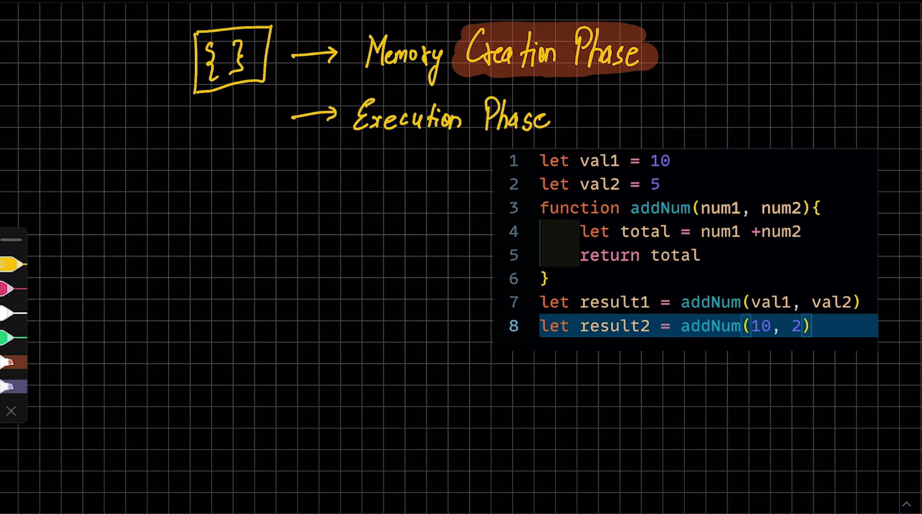

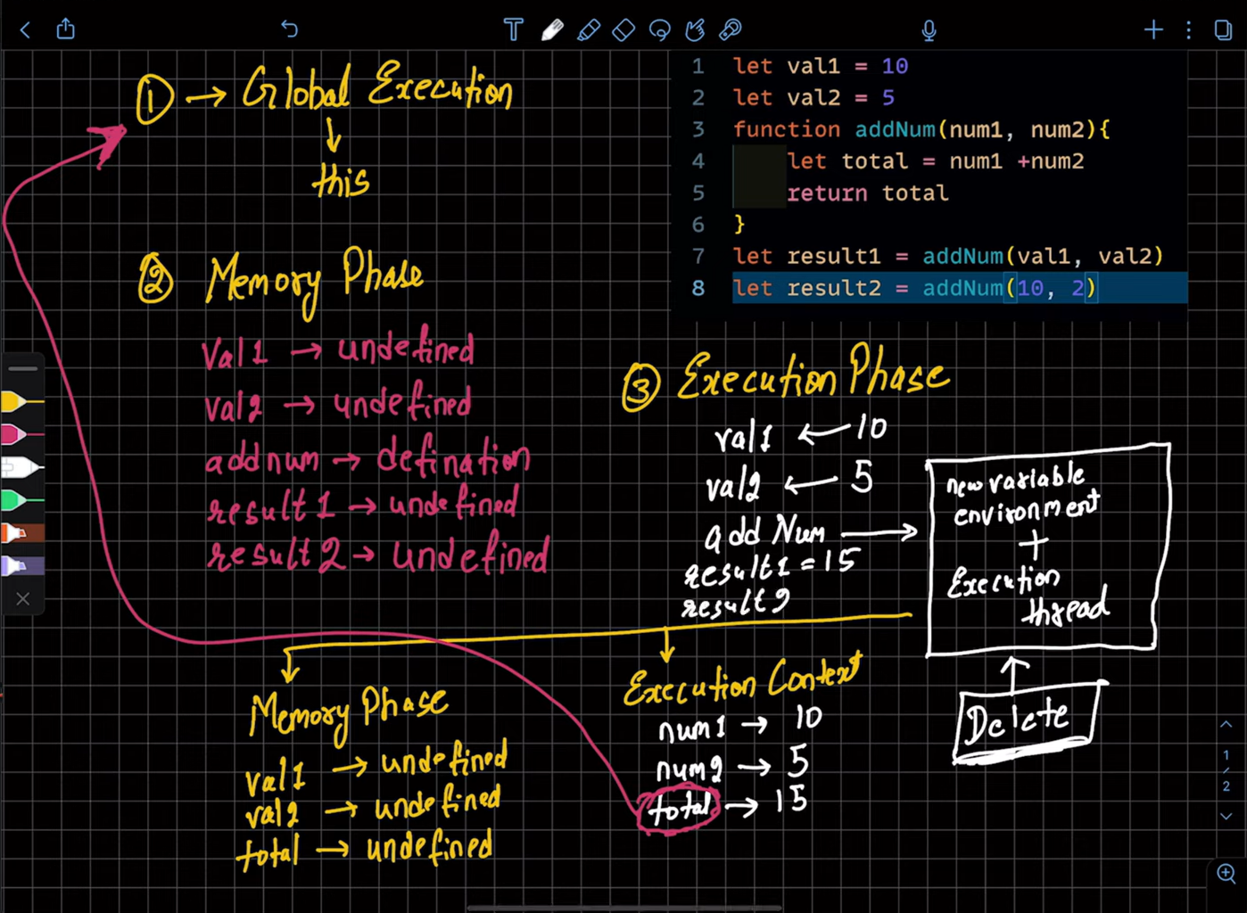

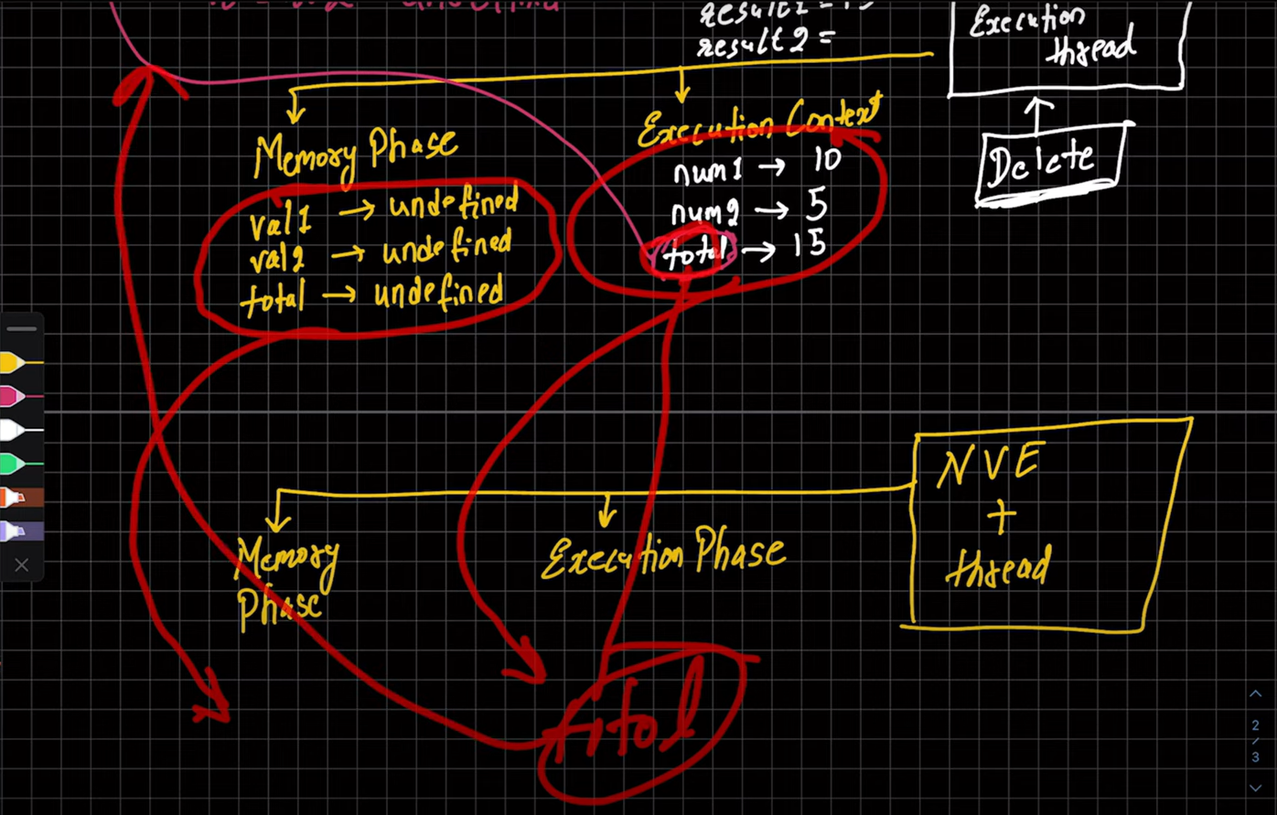

CALL STACK EXECUTION:-



Browser pe right-click inspect elements and open sources and sippets to write code where you give functions and can step by step check the call stack for their execution

